VIETNAM NATIONAL UNIVERSITY – HOCHIMINH CITY
INTERNATIONAL UNIVERSITY
SCHOOL OF ELECTRICAL ENGINEERING

PROJECT’S TOPIC

By
Nguyen VAN A

A thesis submitted to the School of Electrical Engineering in partial fulfillment of the requirements for the degree of
MASTER of Electrical Engineering

Ho chi minh city, viet nam
2023
PROJECT’S TOPIC

BY

Nguyen VAN A (Full name)

Under the guidance and approval of the committee, and approved by its members, this thesis has been accepted in partial fulfillment of the requirements for the degree.

Approved:

________________________________
Chairperson

_______________________________
Committee member

________________________________
Committee member

________________________________
Committee member

________________________________
Committee member

HONESTY DECLARATION

My name is ______________ (full name). I would like to declare that, apart from the acknowledged references, this thesis either does not use language, ideas, or other original material from anyone; or has not been previously submitted to any other educational and research programs or institutions. I fully understand that any writings in this thesis contradicted to the above statement will automatically lead to the rejection from the master program at the International University – Vietnam National University Ho Chi Minh City.

Date:
Student’s Signature

(Full name)

TURNITIN DECLARATION

Name of Student:
Date:

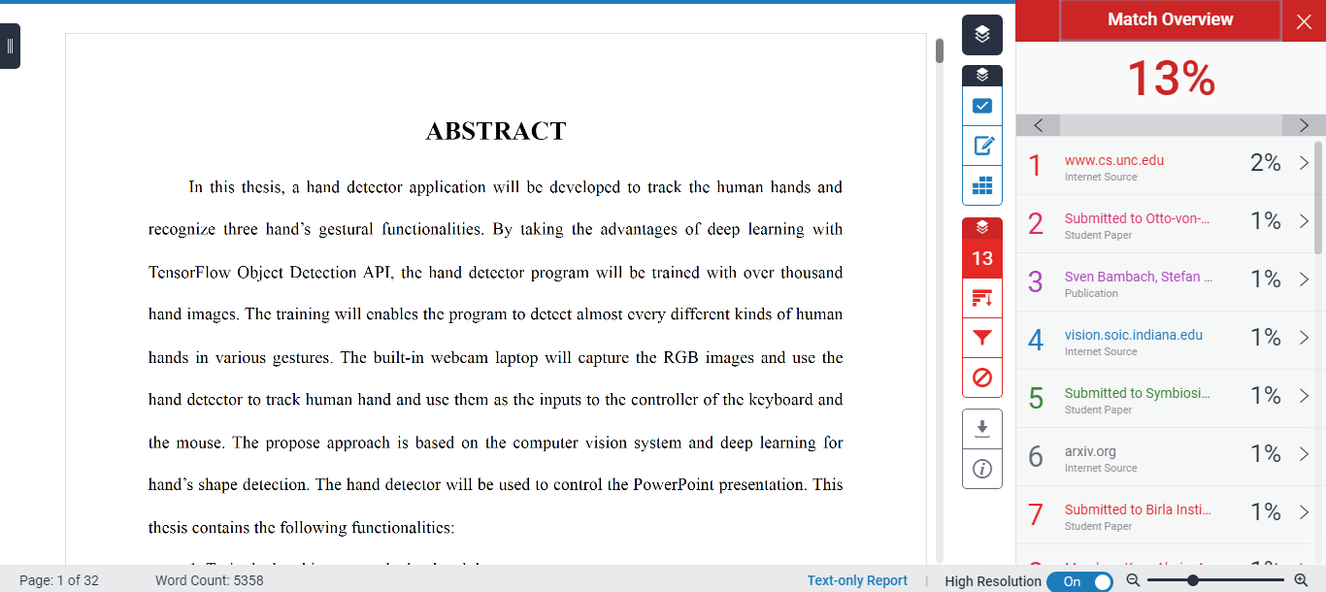

Advisor Signature Student Signature

ACKNOWLEGMENT

It is with deep gratitude and appreciation that I acknowledge the professional guidance of Dr. Nguyen Van B. His constant encouragement and support helped me to achieve my goal.
………………………

TABLE OF CONTENTS

HONESTY DECLARATION ii
TURNITIN DECLARATION iii
ACKNOWLEGMENT iv
TABLE OF CONTENTS v
LIST OF TABLES vii
LIST OF FIGURES viii
ABBREVIATIONS AND NOTATIONS ix
ABSTRACT x
CHAPTER I INTRODUCTION 1
1.1. Level-2 Title 1
1.1.1. Level-3 title 1
1.1.1.1. Level-4 title 1
1.1.1.1.1 Level-5 title 1
CHAPTER II DESIGN SPECIFICATIONS AND STANDARDS 3
2.1. Design Specifications and Standards 3
2.2. Realistic Constraints 3
CHAPTER III PROJECT MANAGEMENT 5
3.1. Budget and Cost Management Plan 5
3.2. Project Schedule 5
3.3. Resource Planning 5
CHAPTER IV LITERATURE REVIEW 6
CHAPTER V METHODOLOGY 7
CHAPTER VI RESULTS 8
CHAPTER VII CONCLUSION AND RECOMMENDATION 9
CHAPTER VIII BUSINESS, SOCIAL AND ETHICAL CONSIDERATIONS 10
REFERENCES 11
APPENDICES 12

LIST OF TABLES

Table 1.1 1
Table 1.2 2
Table 2.1 3
Table 2.2 5
Table 2.3 12
Table 2.4 22

LIST OF FIGURES

Figure 1.1 1
Figure 1.2 1
Figure 2.1 6
Figure 2.2 13
Figure 2.3 22
Figure 3.1 26

ABBREVIATIONS AND NOTATIONS

PAN: Personal Area Network
MAC: Medium Access Control

ABSTRACT

Insert abstract here; it should not exceed one page. Abstract text must be double-spaced with no paragraph breaks. Here are some form and style tips: (a) Limit the abstract to one typed page; (b) maintain the scholarly language used throughout the thesis; (c) keep the abstract concise, accurate, and readable; (d) use correct English; (e) ensure each sentence adds value to the reader’s understanding of the research; and (f) use the full name of any acronym used again in the abstract, and include the acronym in parentheses. Do not include references or citations in the abstract.

CHAPTER I
INTRODUCTION
Your text should begin from here. This is the illustration for the use of the level-1 title style

1.1. Level-2 Title
Your text should begin from here. This is the illustration for the use of the level-2 title style
  - 1. Level-3 title
Your text should begin from here. This is the illustration for the use of the level-3 title style

1.1.1.1. Level-4 title
Your text should begin from here. This is the illustration for the use of the level-4 title style

Level-5 title
Your text should begin from here. This is the illustration for the use of the level-5 title style
The presence of protein bound carbohydrates in the serum was recognized before …. exception of serum albumin, but are particularly prominent in the c-globulin fractions.
It is well known that the concentration of the glycoprotein in human serum is greatly increased in a number …

Table 1.1. Table’s Name
Circuit | V_{ref} (V) | I_{ref} (mA) | I_{ref2} (mA)
Circuit 1 | 0.01 | 1 | 2
Cirucit 2 | 0.1 | 2 | 3
Etc.
Table 1.2. Table’s Name
Circuit | V_{ref} (V) | I_{ref} (mA) | I_{ref2} (mA)
Circuit 3 | 0.01 | 1 | 2
Cirucit 4 | 0.1 | 2 | 3
Etc.

Figure 1.1. Figure’s Name
Figure 1.2. Figure’s Name

CHAPTER II
DESIGN SPECIFICATIONS AND STANDARDS

2.1. Design Specifications and Standards

2.2. Realistic Constraints

Table 2.1. Table’s Name
Circuit | V_{ref} (V) | I_{ref} (mA) | I_{ref2} (mA)
Circuit 1 | 0.01 | 1 | 2
Cirucit 2 | 0.1 | 2 | 3
Etc.
Table 2.2. Table’s Name
Circuit | V_{ref} (V) | I_{ref} (mA) | I_{ref2} (mA)
Circuit 3 | 0.01 | 1 | 2
Cirucit 4 | 0.1 | 2 | 3
Etc.

Figure 2.1. Figure’s Name

CHAPTER III
PROJECT MANAGEMENT

The project management plan is a single, formal, dynamic document that outlines how the project is to be managed, executed, and controlled. It contains the overall project governance and related management plans and procedures, timelines, and the methods and accountabilities for planning, monitoring, and controlling the project as it progresses. This document evolves with the project and will be updated to reflect any relevant changes throughout project execution. This document should ensure there are no surprises through execution on how the project is managed or decisions are made.

3.1. Budget and Cost Management Plan
Provides a description of how the costs of the project will be managed. Provides the details of the cost of all of the components and devices required for the project.

3.2. Project Schedule
This section should describe the approach for creating, updating, and monitoring the project schedule. This section should also include information on the scheduling tools/formats to be used, and schedule development roles and responsibilities. The schedule should account for tasks, priorities, dependencies, and milestones.

3.3. Resource Planning
Describes the resource required for the project. Clearly identifies the roles, tasks, and responsibilities for each of the team members.

CHAPTER IV
LITERATURE REVIEW

CHAPTER V
METHODOLOGY

CHAPTER VI
RESULTS

CHAPTER VII
CONCLUSION AND RECOMMENDATION

CHAPTER VIII
BUSINESS, SOCIAL AND ETHICAL CONSIDERATIONS

REFERENCES
[1] | C. N. E. Anagnostopoulos, "License plate recognition: A brief tutorial," IEEE Intelligent transportation systems magazine, vol. 6, no. 1, pp. 59–67, Jan. 2014.
[2] | W. Jackson, Learn Android App Development, Apress, 2013.
[3] | K. Aida-zade, E. Mustafaev, and J. Hasanov, "Intelligent reading system based on mobile platform," in International Conference on Problems of Cybernetics and Informatics, Baku, Azerbaijan, 2012, pp. 1-4.
[4] | A. Mutholib, T. S. Gunawan, and M. Kartiwi, "Design and implementation of automatic number plate recognition on android platform," in International Conference on Computer and Communication Engineering, Kuala Lumpur, Malaysia, 2012, pp. 540–543.

APPENDICES

Footnote

